CITIZEN’S SUMMARY
2022 Annual Implementation Report

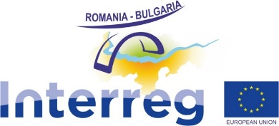

Thanks to a constant and fruitful cooperation between Joint secretariat, Managing authority, National authority and the beneficiaries, Interreg Romania-Bulgaria Programme registered significant achievements during 2022.
Based on a continue dialogue between all the involved parties, we reached a common approach to address the specific challenges encountered during 2022, so that the financed projects produced visible results for the benefit of the citizens of Romania – Bulgaria cross border.

In terms of implementation, out of the total 169 projects, 140 have been successfully completed and have generated positive outcomes in the area. In 2022, 20 additional projects finalized their implementation, resulting in an overall implementation success rate of 82.84% by the end of 2022. The remaining 29 projects, with a total budget of €115,062,740.83 million, are still under implementation. All of these projects have made a significant impact on local communities, addressing challenges related to nature and climate changes within the program area.

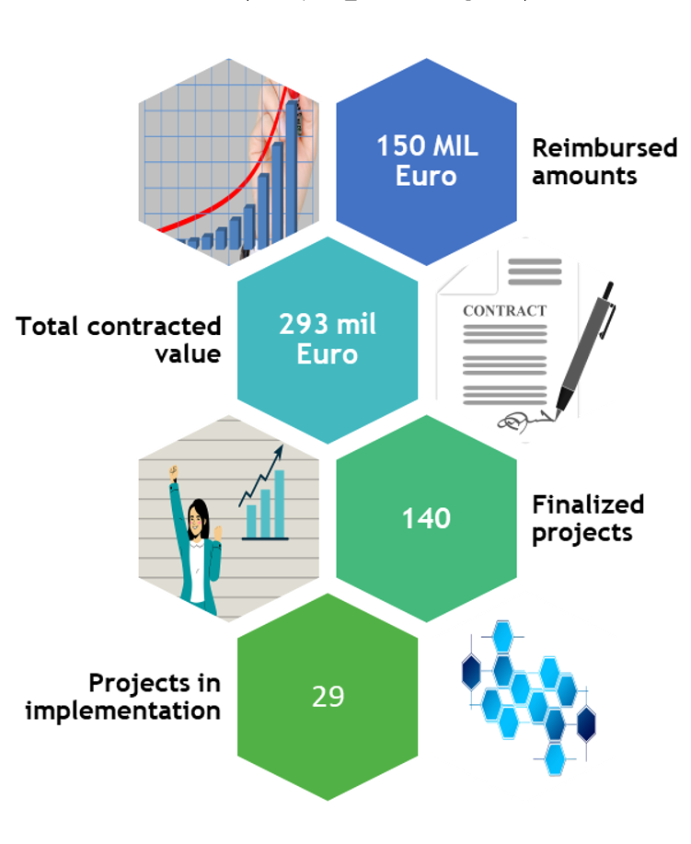

Despite the ongoing Covid-19 pandemic and conflicts in Ukraine, the projects have delivered positive outcomes and exceeded their predetermined targets.

Notably, the implementation of projects under PA 1, 2, and 3 has resulted in the achievement of five output indicators:
- Supporting the development of studies, strategies, and action plans aimed at enhancing safety in navigation on the Danube and the Black Sea;
- Considerable increase in the total length of improved or newly created inland waterways;
- Increase in the expected number of visits to supported cultural and natural heritage sites and attractions;
- Creation of several integrated tourism products/services;
- Improvement of the surface area of habitats, thus contributing towards better conservation status.

PA4, A Skilled and Inclusive Region, and PA5, An Efficient Region, have been successfully implemented, with all indicators being met.

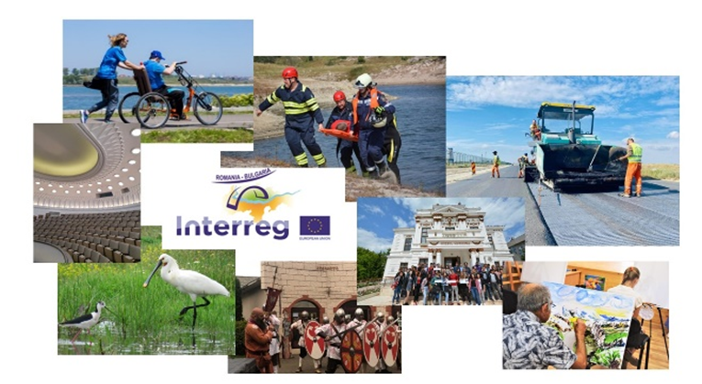

Under PA4, projects have enabled 899,462 individuals to access employment opportunities through training and support mechanisms, thereby empowering and facilitating the workforce in the cross-border area. 215 initiatives promoting workforce mobility have been implemented, with 41,228 people directly participating in these programs. Furthermore, 15,989 participants have directly benefited from joint educational and training schemes aimed at supporting youth employment, educational opportunities, and vocational education. A comprehensive list of project outputs financed under PA4 is available at https://www.interregrobg.eu/ro/projects/
In terms of PA5, the main output has been the development of joint initiatives and mechanisms that enhance cross-border cooperation in the program area. A total of 103 cross-border mechanisms, including agreements, networks, studies, policies, strategies, and information exchange tools, have been developed. These mechanisms have directly contributed to the capacity building of stakeholders in various fields, such as education, social policies, health, tourism, and Danube navigation.

The communication and promotion activities carried out during 2022 were focused on presenting the results of the projects through online campaigns (website, social media) and events with a physical presence. An online campaign to promote FB projects involving youth, in the context of the European Year of Youth, was carried on. To celebrate European Cooperation Day 2022, an event dedicated to youth, “Bike ride for cooperation”, gathering more than 250 participants was organized on the bike trail from the seafront promenade in Balcic (Bulgaria), on 27th of September 2022. As well, beneficiaries of the projects had the opportunity to present the results of the implemented projects to the general public during the Annual Conference of the Programme that took place in Craiova, on the 14th of December 2022.
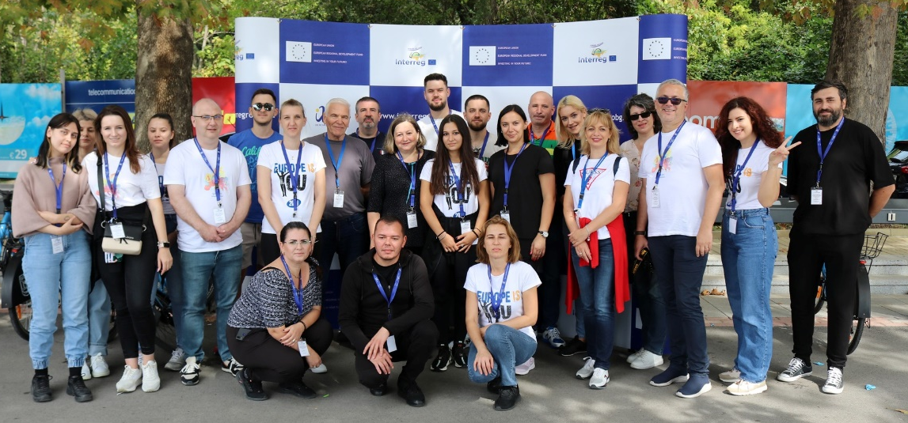
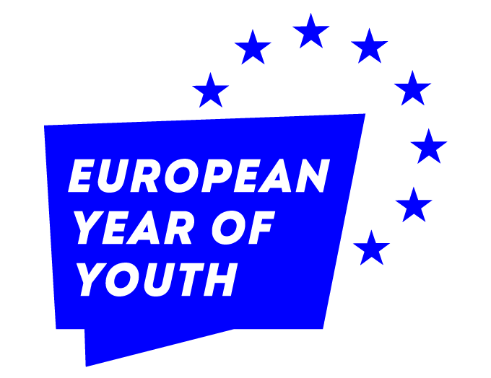

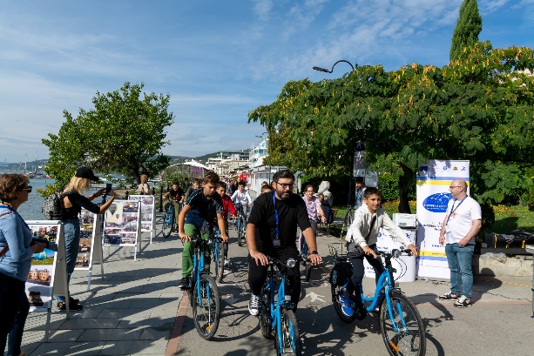
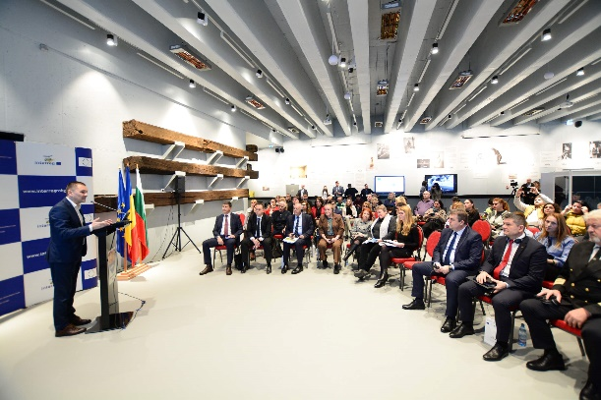

If you don't think about the future, you cannot have one
During 2022, the Programme managing structures made important progress in the programming process for the 2021-2027 period. Therefore, the Interreg VI-A Romania-Bulgaria Programme was approved by the Joint Working Group for Programming (JWG) during the third meeting organized on February 3rd, 2022, before being submitted for approval to the European Commission (EC). As a result, the Programme Interreg VI-A RoBg was sent to the EC on 1st of April 2022 and approved by the EC on the 30th of November 2022.

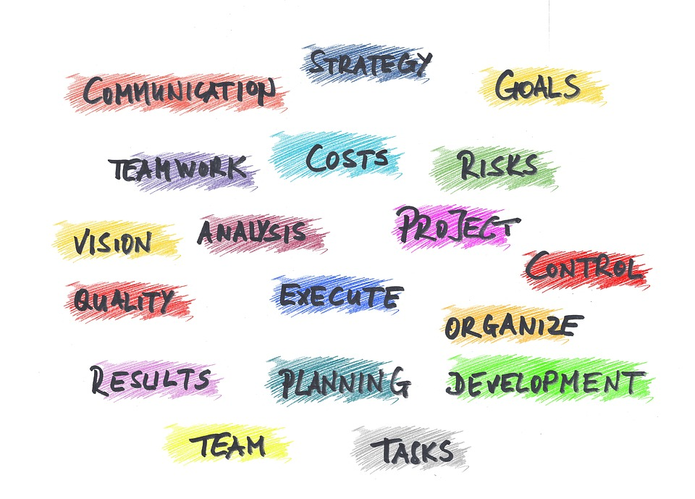
Stay tuned for more news and information about upcoming events: www.interregrobg.eu
Follow us on social media:
https://www.facebook.com/RomaniaBulgariaCbcProgramme?ref=ts
https://twitter.com/ROBGProgramme
https://www.youtube.com/channel/UCtgRgCcdOK5D2ZsBJrMPXew/videos
https://www.linkedin.com/company/interreg-romania-bulgaria/
https://www.instagram.com/interregviarobg/

